1.Grade Checker
This program is written using else-if statements.
It takes score as an input(integer) and compares with the conditions provided and according to the score it prints the grade.
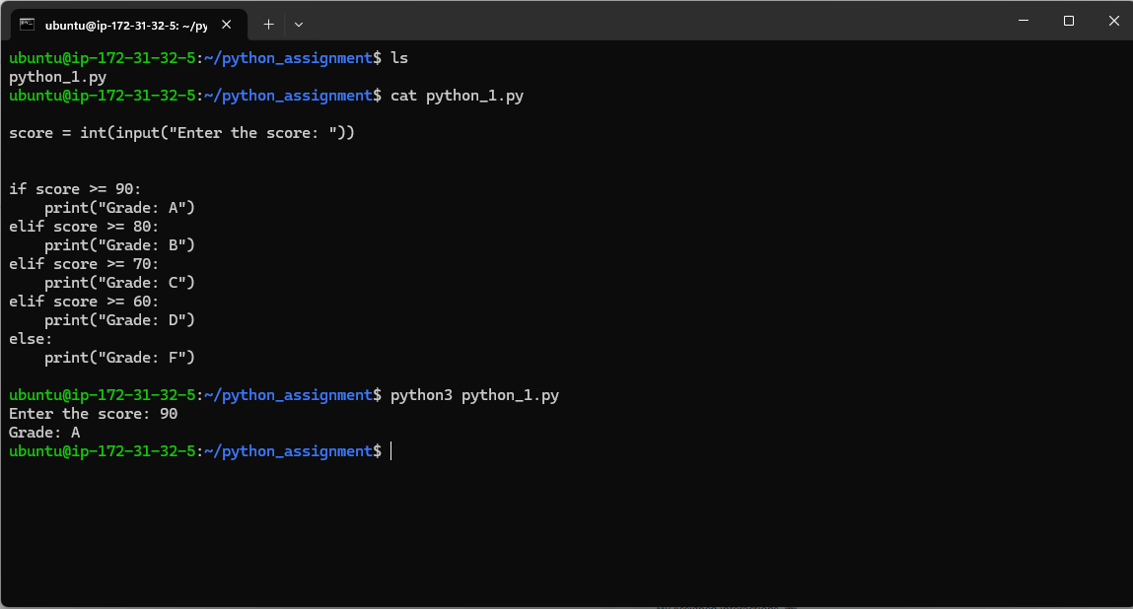

2. Student Grades
An empty dictionary students is created.
Name and grade are taken as an input
If condition is used to check the name entered is present if not a new student name is added.
Students[name] = grade : this statement helps to update the grade of a student if name is already exists.
For loop is used to print all students with a key : value pair.
Can use while loop to increase number of students in a dictionary

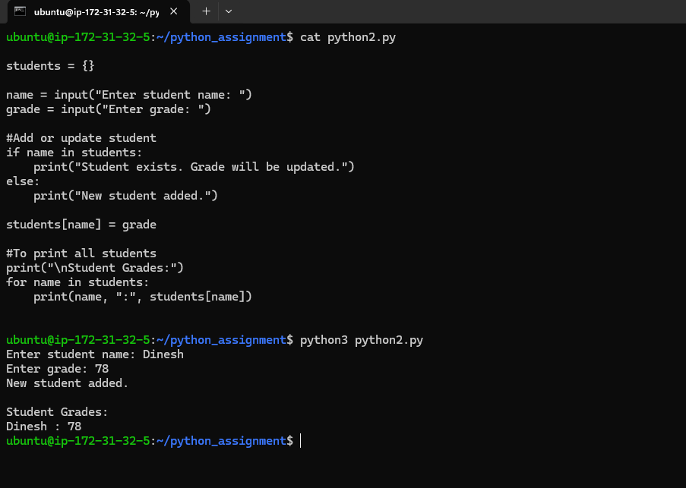

3 . .Write to a File
4. Read from a File
This both pragrams are written as per the task given
First it opens a file and “w” is given to create a file if its not there already.
- file.write is used to write a new message into the file
- file.close() is used to close the file as it was opened previously.
Similarly for Read a file program
- a file is opened and a file is read and it is assigned as content, the content read is asked to print and the file is closed at last.
